The Desk Buddy Made Simple
In the Age of Inflation, students and workers alike are looking for ways to cut costs from their supplies budget. The following guide will show how to create a Desk Buddy, a small office basket to house pens, pencils, staples, and the likes. This little convenient holder can be made from a few common household items.

Supplies You Will Need
- Two sheets of paper (of different colors or the same)
- Tape (preferably clear)
- Ruler (12 inches)
- Scissors
- Optional: Marker (a pen or pencil will work as well)
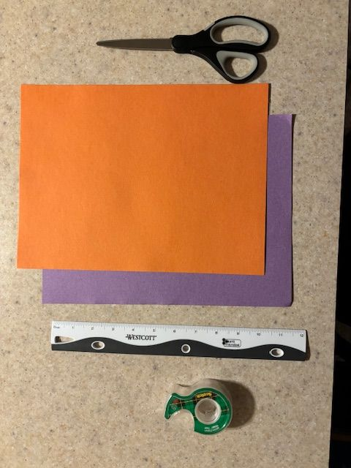

Step 1
A. Cut one sheet of paper into strips about 2 cm wide. The ruler can be used to measure them out while the marker can note where to cut.
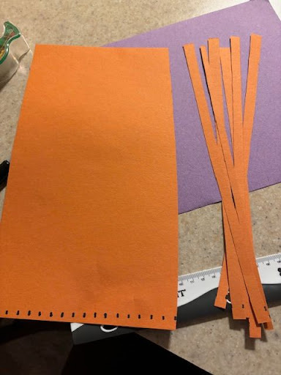
B. Cut the other sheet of paper similar to the strips but not all the way across. The ruler and marker can be utilized here as well. The paper can also be folded in half to make cutting it easier.
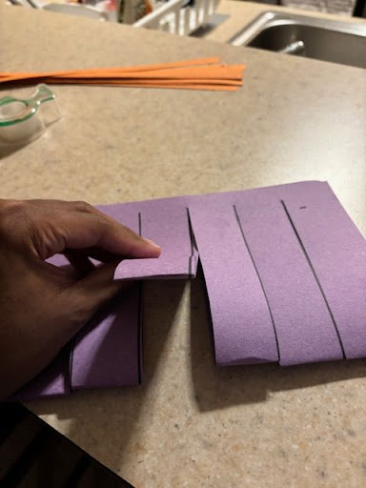

Step 2
A. Weave the strips from the other sheet through the cut paper. For successful weaving, go in the opposite direction for each strip (i.e. if starting over, under, over, under, the next strip should be under, over, under, over and vice versa).
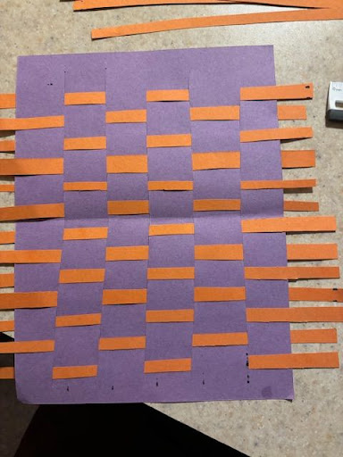
B. Once the strips reach all the way across the sheet, tape them down at ends of the woven paper on both sides.
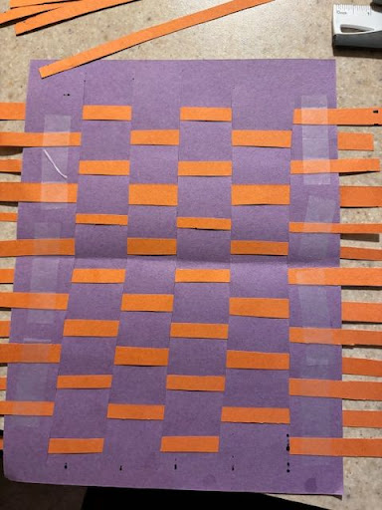

Step 3
A. Fold the woven paper inward on both sides at about 1 inch.
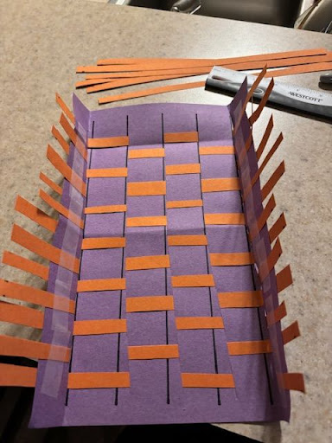
B. To close the basket into a rectangle, cut it at the opposite ends and fold them in as well, then secure the 4 walls with more tape.
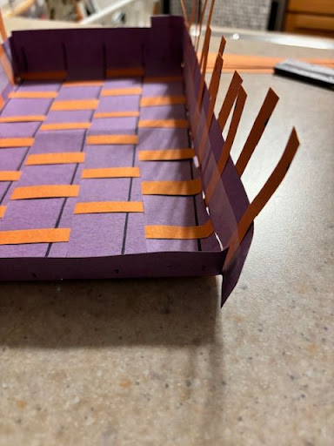
C. For cosmetic reasons, you can cut off the excess length from the strips. Once done, position the new Buddy on your desk for your convenience!
